Digital Image Processing
/
12
5/2024

CS 457
Semester 7th
DIP Lab Exam
Muhammad Kashif Khan NIM-BSCS-2021-14

Qno.01: Load the given image and count the total number of objects (8-connected) and the total number of object pixels.

# Step 1: Load the image and count 8-connected objects and object pixels

import cv2
import numpy as np
import matplotlib.pyplot as plt

# Load the input image
image_path = '/content/PracticalExamImage.bmp' # Change to your image path
image = cv2.imread(image_path)

# Convert to grayscale
gray = cv2.cvtColor(image, cv2.COLOR_BGR2GRAY)

# Apply binary thresholding
_, binary_image = cv2.threshold(gray, 127, 255, cv2.THRESH_BINARY_INV)

# Count connected components (8-connectivity)
num_labels_8, labels_8, stats_8, centroids_8 = cv2.connectedComponentsWithStats(binary_image, connectivity=8)

# Count total number of object pixels
object_pixels_8 = np.sum(binary_image == 255)

# Display the binarized image
plt.imshow(binary_image, cmap='gray')
plt.title(f'Binarized Image - 8-Connected Objects: {num_labels_8 - 1}, Pixels: {object_pixels_8}')
plt.axis('off')
plt.show()

print("8-Connected Objects:", num_labels_8 - 1)
print("Total Object Pixels:", object_pixels_8)

OUTPUT:

8-Connected Objects: 11
Total Object Pixels: 7032

Qno.02: Binarize the image and count the total number of objects (8-connected) and the total number of object pixels

# Step 2: Convert to binary and recount (8-connectivity)

# Count connected components after binarization using 8-connectivity
num_labels_bin_8, _, _, _ = cv2.connectedComponentsWithStats(binary_image, connectivity=8)

print("Binarized Image - 8-Connected Objects:", num_labels_bin_8 - 1)

OUTPUT:
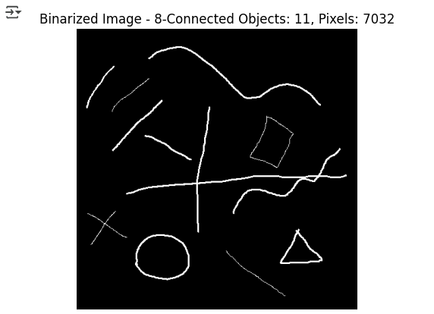

Qn0.03: Convert each object into a single pixel thick object and count the total number of objects and the total number of object pixels.

# Step 3: Skeletonize the objects and recount

from skimage.morphology import skeletonize

# Convert binary image to boolean for skeletonization
binary_bool = binary_image > 0

# Perform skeletonization
skeleton = skeletonize(binary_bool)

# Count total number of skeletonized object pixels
skeleton_pixels = np.sum(skeleton)

# Count 8-connected components in skeletonized image
skeleton_uint8 = (skeleton * 255).astype(np.uint8)
num_labels_skel, _, _, _ = cv2.connectedComponentsWithStats(skeleton_uint8, connectivity=8)

# Display skeletonized image
plt.imshow(skeleton, cmap='gray')
plt.title(f'Skeletonized Image - Objects: {num_labels_skel - 1}, Pixels: {skeleton_pixels}')
plt.axis('off')
plt.show()

print("Skeletonized Objects:", num_labels_skel - 1)
print("Skeletonized Object Pixels:", skeleton_pixels)

OUTPUT:

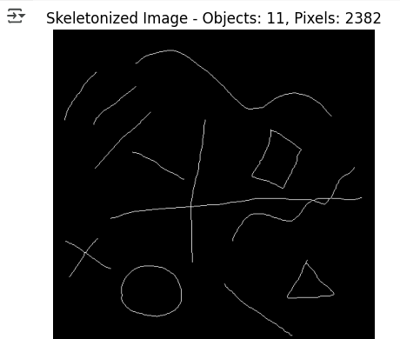

QNo.04: Now instead of 8-connectivity use 4-connectivity and count the total number of objects.

# Step 4: Count objects using 4-connectivity

# Count connected components (4-connectivity)
num_labels_4, labels_4, stats_4, centroids_4 = cv2.connectedComponentsWithStats(binary_image, connectivity=4)

# Display the image with 4-connectivity result
plt.imshow(labels_4, cmap='nipy_spectral')
plt.title(f'4-Connected Objects: {num_labels_4 - 1}')
plt.axis('off')
plt.show()

print("4-Connected Objects:", num_labels_4 - 1)

OUTPUT:

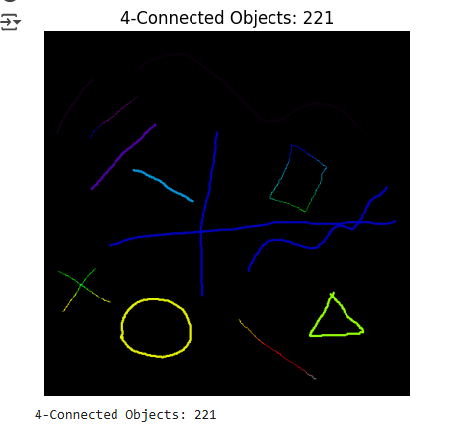

QNO.05: Design and implement a method which converts the 8-connected objects into 4-connected objects with least number of extra pixels added. Once the objects are converted into the 4-connected objects count the objects and the total number of object pixels.

# Step 5:

from scipy.ndimage import binary_dilation

# Convert 8-connected components to 4-connected with minimal extra pixels
kernel = np.array([[0, 1, 0],
[1, 1, 1],
[0, 1, 0]], dtype=np.uint8) # 4-connectivity structuring element

four_connected = binary_dilation(binary_image, structure=kernel)

# Count connected components after conversion to 4-connectivity
four_connected_uint8 = four_connected.astype(np.uint8) * 255
num_labels_conv_4, _, _, _ = cv2.connectedComponentsWithStats(four_connected_uint8, connectivity=4)

# Display the modified 4-connected image
plt.imshow(four_connected, cmap='gray')
plt.title(f'Converted to 4-Connected Objects: {num_labels_conv_4 - 1}')
plt.axis('off')
plt.show()

print("Converted 4-Connected Objects:", num_labels_conv_4 - 1)
print("Total Object Pixels (converted):", np.sum(four_connected))

OUTPUT:

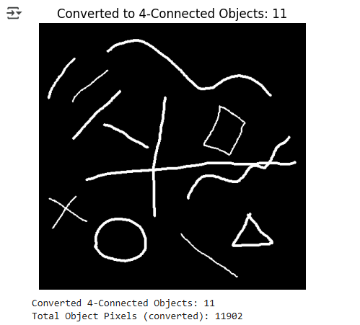

Chatgpt prompts
1)analyse the document and understand the questions first
2)this is the image which is required to be processed with above questionair. give python code for each question according to the given image to be processed as well
3) give code for each question seperately
4) AttributeError: module 'numpy' has no attribute 'int'. np.int was a deprecated alias for the builtin int. To avoid this error in existing code, use int by itself. Doing this will not modify any behavior and is safe. When replacing np.int, you may wish to use e.g. np.int64 or np.int32 to specify the precision. If you wish to review your current use, check the release note link for additional information. The aliases was originally deprecated in NumPy 1.20; for more details and guidance see the original release note at: https://numpy.org/devdocs/release/1.20.0-notes.html#deprecations for question 1
5) behavior and is safe. When replacing np.int, you may wish to use e.g. np.int64 or np.int32 to specify the precision. If you wish to review your current use, check the release note link for additional information. The aliases was originally deprecated in NumPy 1.20; for more details and guidance see the original release note at: https://numpy.org/devdocs/release/1.20.0-notes.html#deprecations issue in question 4
6) /usr/local/lib/python3.11/dist-packages/scipy/ndimage/_measurements.py in label(input, structure, output) 181 structure = numpy.asarray(structure, dtype=bool) 182 if structure.ndim != input.ndim: --> 183 raise RuntimeError('structure and input must have equal rank') 184 for ii in structure.shape: 185 if ii != 3: RuntimeError: structure and input must have equal rank
7) TypeError Traceback (most recent call last) <ipython-input-10-3a681c64ca83> in <cell line: 0>() 11 12 # Ensure the binary image is a 2D array ---> 13 binary_image = binary_image // 255 # Normalize to binary (0 and 1) 14 15 # Define the 4-connectivity structure TypeError: unsupported operand type(s) for //: 'NoneType' and 'int'

